Caitlyn Jones
Prof. Yangyang Wang
MATH 40A: Intro to Applied Math
23 October 2024
Homework 3

  - In process.py, I created a function process_image(image), where image is the original image that will be converted to black and white; the ball will be white, and everything else will be black. To begin, I wrote the first three lines process.py into process_image(image). Then, I added a statement to ensure that the shape is in range. Then, I converted the rgb image to hsv and created the upper and lower bounds for the color of the blue hue. Then, I isolated the ball using the range in hue in order to make it white and the background black. I then denoised the image to remove all the extra white space. Lastly, to see the images, I ran process_image(image) seven times in order to show the progression of the ball dropping.
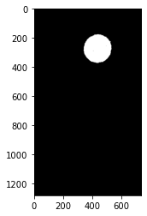
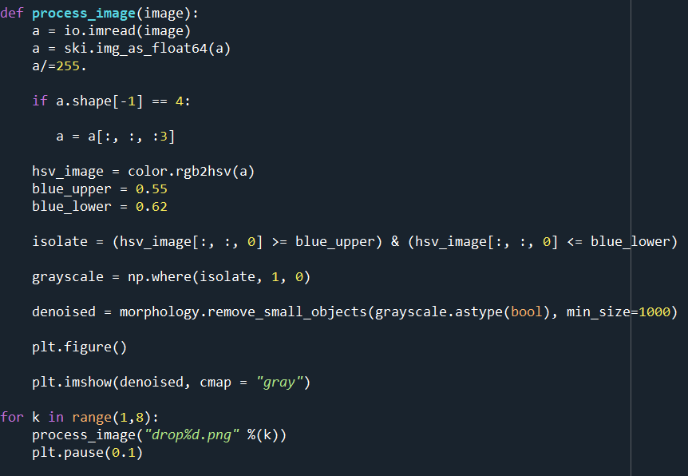
Here are the results.
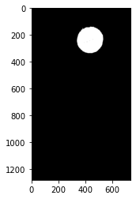
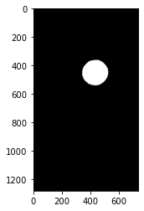
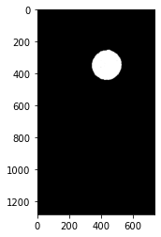

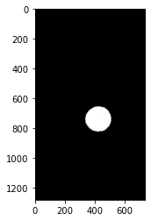
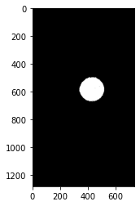

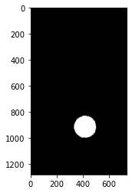

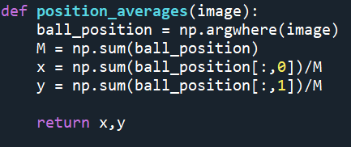
  - To compute the averages, I created a function position_averages(image) to do so. I first computed M, which is the sum of the pixels for the position of the ball. From there I was able to compute x and y, which are the averages of the x and y positions for the ball. To run this function, I called it in process_image(image).

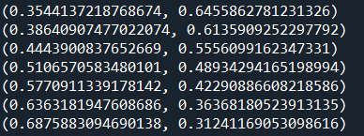

  - To examine the measuring tape in the images, I first read the original image into the console, adding a grid for better accuracy.
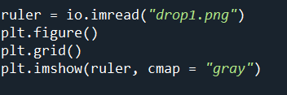

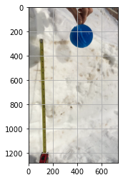

Then, I determined that one inch is equivalent to about 44.4 pixels.
First, I need to find the velocity.
$$v= \frac{∆x}{∆t}$$
$$v= \frac{5}{5/24}$$
$v= 24 in/s$, in meters $v= .6096 m/s$
Then, I can find the acceleration due to gravity.
$$g= \frac{∆v}{∆t}$$
$$g= \frac{.6096}{5/24}$$
$$g= 2.92608 m/s^{2}$$
  - The ball does continue to accelerate in the last two images

  - To plot the first and second columns of the Radon transformation, I created a figure with a legend to ensure that both plots are on shown on the figure.
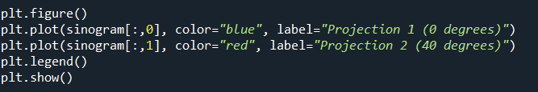

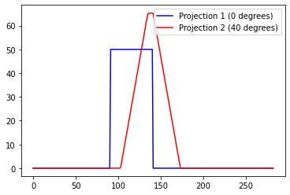
Here is the result.

These projections do make sense; projection one is strictly the original image going through a Radon transformation, which I can see reflected in the figure. Projection two is taken from lines that form 40-degree angles with respect to the horizontal; I can see that reflected in the figure because looking closely at the peak of projection two, there is a straight line, which shows that the original image was a square but was skewed in some way.
  - I added the given code to the program to produce the following image, which is the inverse transformation of the original image.
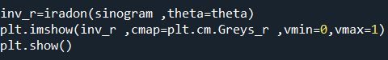

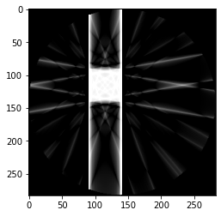

The above image depicts the inverse transformation, where you can see the projections of the various angles. Then I changed the angles to produce the following image.

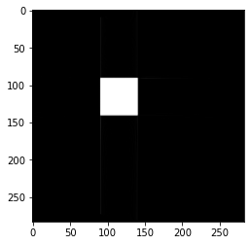

The image above is worse than the old image, as it is the same as the original image. The image is worse because it does not show any projections/shadows.
  - To get the transformation below, I used the original image as a white circle in a black image.
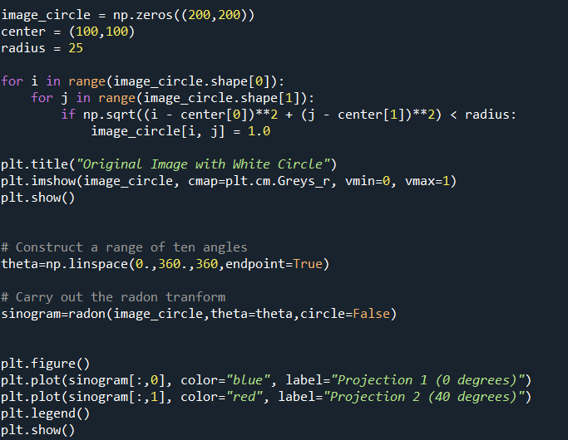

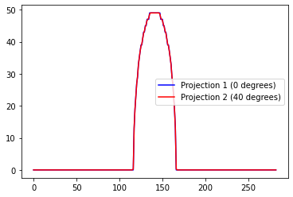
Here are the results.

